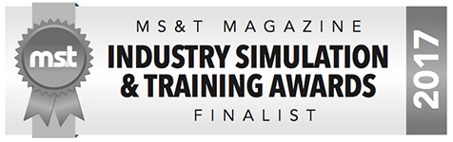

Eduworks Corporation Named Finalist in Military Simulation and Training Magazine’s 2017 Industry Simulation & Training Awards
CORVALLIS, OR – Eduworks Corporation (Eduworks) announced today that it has been selected as a finalist in Military Simulation and Training (MS&T) Magazine’s 2017 Industry Simulation & Training Awards. For 15 years MS&T’s Industry Simulation & Training Awards have recognized excellence in companies making significant impacts to the military training industry during the current calendar year. MS&T has been a leading defense training journal for over 30 years. Award winners are selected by MS&T’s highly experienced editorial board. Eduworks was a Military Simulation and Training Magazine award winner in 2014 and 2015.
Dr. Robby Robson, Eduworks CEO, noted “Providing innovative training technology solutions that improve human performance is an important part of the Eduworks mission. This recognition from MS&T is a testament to the dedication and success of our team in fulfilling this mission for our military customers. We are honored to have received it.”
MS&T’s Industry Awards winners list appears in MS&T’s Issue 4 (September/October) and is available online at http://www.awards.mstmagazine.com.
Contact:
Eduworks Corporation
info@eduworks.com
+1 (541) 753-0844

